1. **INTRODUCTION**
   1. Overview

A social media post is a short-form type of content or message that gets published on social media platforms such as Facebook, Instagram, Twitter, LinkedIn, and other similar channels. It takes several different forms that result from mixing text, images, videos, links, and audio files.

2.2 purpose

Social media posts are an important part of any social media marketing strategy. They allow businesses to build a community around their brand and establish a meaningful presence in the online space.

1. Problem Definition & Design Thinking
   1. Empathy map

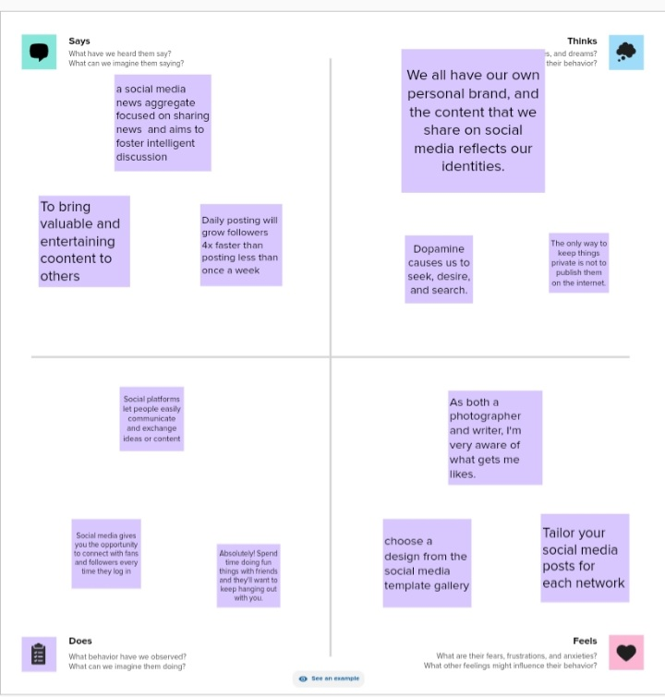

* 1. Ideation & Brainstorm map

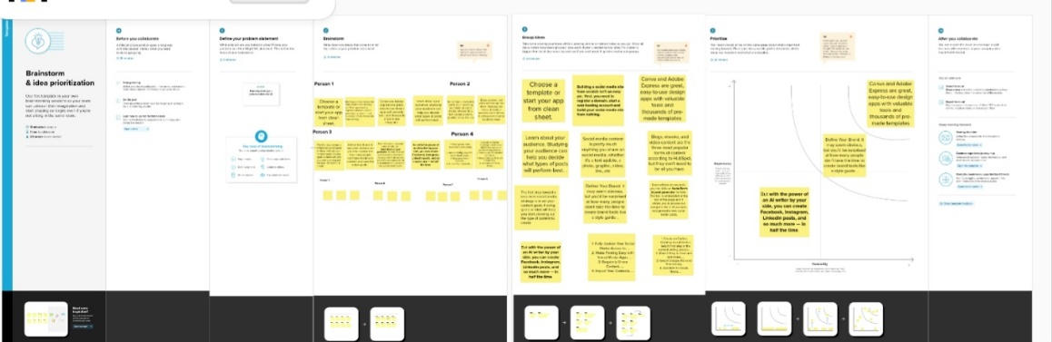

1. Result



1. **ADVANTAGES & DISADVANTAGE**

Advantage

A positive in using social media in reporting is that the news does get spread fairly quickly. If the information is correct then it can be an excellent way of getting the news out before waiting and waiting for something along the lines to be printed on paper hours or days later.

Disadvantage

The study also finds that those who do get their political news primarily through social media tend to be less well-informed and more likely to be exposed to unproven claims that people who get their news from traditional source

**5 APPLICATION**

I have used mural app and canva app.

**6. Conclution**

We have created social media post with the help of canva.

7. Future scope

We were planning to join the graphic designing course.